TWU  Professor H. Janzen  Time: 2 hours | Ma 101  Final Exam  Finite Mathematics | Name: ___________________

Part I – General Knowledge – 2 marks each. Circle the best choice.

- If the total cost of P articles is Q dollars, then the cost, in dollars, of R articles of the same type is
(a) 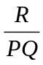 (b) 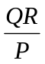 (c) PQR (d) 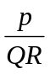 (e) 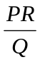

- A sailboat leaves the dock and sails 12 km west, then 9 km north. At this time, its shortest distance from the dock, in km is
(a) 108 (b) 3 (c) 225 (d) 15 (e) 21
- When Gauss was a young lad he discovered that the sum, S, of the first n natural numbers is given by the formula 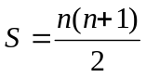. The sum of the first 30 natural number is
(a) 901 (b) 930 (c) 232.5 (d) 465 (e) 240
- The number of different values of a for which the given triangle is isosceles is
(a) 2 (b) 3 (c) 0
(d) 1 (e) more than 3
5a - 16
3a - 8
3a - 6
- P is the center of square WXYZ and R is the midpoint of WZ. If the area of PXR is 3, then the shaded area is
(a) 18 (b) 15 (c) 21
(d) 24 (e) 12
Z
R
Y
X
W
P
- A rectangular picture, 1.2 m wide, is centered on a wall that is 5 m wide. What is the distance, in meters, from the edge of the wall to the nearest edge of the picture?
(a) 0.6 (b) 1.9 (c) 3.8 (d) 3.1 (e) 1.3
- Notice that 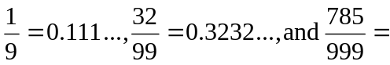0.785785… Using this pattern, 0.41144114… equals
(a) 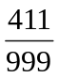 (b) 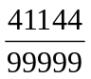 (c) 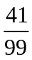 (d) 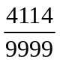 (e) none of these
- The ratio of the number of red marbles to the number of green marbles in a container is 1:3. If there are 48 marbles altogether, then the number of green marbles is
(a) 32 (b) 36 (c) 12 (d) 24 (e) 16
- The value of 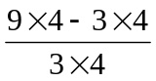 is
(a) 35 (b) 3 (c) 2 d) 5 (e) 36
- The value of 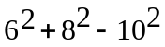 is
(a) 200 (b) 32 (c) 0 (d) 8 (e) 16
- If 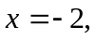 the value of 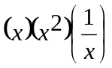 is
(a) -8 (b) -4 (c) 16 (d) 4 (e) 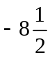
- When a certain number is divided by 9, the quotient is 6 and the remainder is 4. The number is
(a) 67 (b) 49 (c) 58 (d) 42 (e) 33
- The sum of nine consecutive positive integers is 99. The largest of the integers is
(a) 19 (b) 7 (c) 11 (d) 15 (e) 9
- The number of positive integers between  and 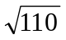 is
(a) 9 (b) 50 (c) 7 (d) 10 (e) 6
- 3² x 3³ x 3⁴ is equal to
(a) 27²⁴ (b) 27⁹ (c) 9⁹ (d) 3⁹ (e) 3²⁴
Part II – Topics covered in Math 101: 2 marks each. Circle the best choice.

- Find the minimum value of the function 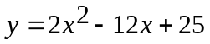
(a) 7 (b) -12 (c) 25 (d) 3 (e) 0
- Determine x if 4^{4x + 2} = 32^{x – 1}
(a) 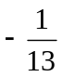 (b) 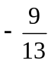 (c) -3 (d) -2 (e) there is no solution
- On each application of killer week spray, 80% of the weeds are killed. On a test plot there are 275 weeds. After the plot has been sprayed twice, the number of weeds remaining is:
(a) 176 (b) 115 (c) 11 (d) 74 (e) 44
- Two circles have diameters 5 and 15 respectively, then the ratio of their areas is
(a) 1:4 (b) 1:3 (c) 1:2 (d) 1:9 (e) none of these
- What is the sum of the first 100 positive multiples of 5?
(a) 24750 (b) 25250 (c) 500 (d) 1050 (e) none of these
- The n^{th} term in the sequence
, 1, 3, 9 . . . is
(a) 3^{n} (b) 3^{n –} ¹ (c) 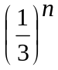 (d) 3^{n –2} (e) none of these
- 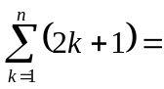
(a) (n + 1)² (b) n(n + 2) (c) n(n + 1) (d) n² (e) none of these
- If a₁ x + b₁ y = c₁ and a₂x + b₂y = c₂ are parallel then
(a) a₁ b₁ = a₂b₂ (b) a₁b₂ = a₂b₁ (c) a₁ = a₂ (d) 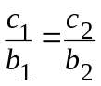 (e) none of these
- The n-th term of the sequence -1, 2, 5, … is given by the expression:
(a) 3n-4 (b) 3n-2 (c) -3n+3 (d) 2n-2 (e) none of these
- When simplified, the product
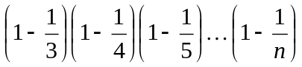 is:
(a) 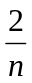 (b) 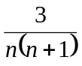 (c) 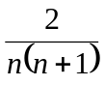 (d) 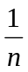 (e) 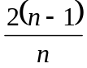
- For a certain series S_{n}=3^{n+1}, determine t₃.
(a) 27 (b) 54 (c) 81 (d) 18 (e) none of these
- A point, P, divides the line segment AB in a ratio of 3:4; that is 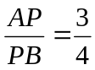. If A=(9, 12) and B=(2,3), find the x-coordinate of point P.
(a) 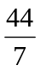 (b) 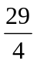 (c) 6 (d) 5 (e) none of these

- Simplify 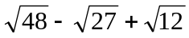
(a) 3 (b) 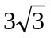 (c) 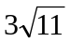 (d) 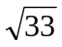 (e) 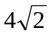
- 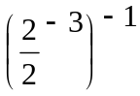 is equivalent to
(a) 16⁻¹ (b) -16 (c) 4 (d) 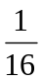 (e) 16
- If f(x)=x² and g(x)=2x-3, find f(g(2))
(a) 2 (b) 4 (c) 5 (d) 1 (e) none of these
- Simplify 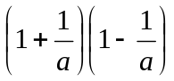
(a) 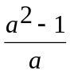 (b) 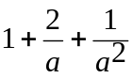 (c) 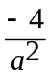 (d) a² - a (e) none of these
- The expression (2x-5)² – 3(x-7) can be written in the form
(a) 4x² – 23x + 46 (b) 4x² (c) 4x² - 3x + 45 (d) 4x² - 3x + 4 (e) 4x² – 3x – 32
- A circle, with center (-2,3), goes through the point (5,-6). Determine the length of the radius to 1 decimal place.
(a) 11.4 (b) 16.0 (c) 9.5 (d) 7.6 (e) none of these
- What is the equation of the axis of symmetry of the parabola 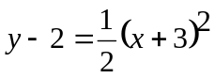
(a) 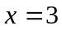 (b) 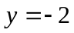 (c) 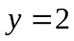 (d) 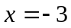 (e) none of these
- How many intersections are there for the graphs represented by the following system?
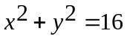
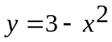
(a) 4 (b) 3 (c) 1 (d) 2 (e) they don’t intersect
Part III – Open ended questions. (5 marks each). You must show all your work for full marks.

- Simplify each expression.
(a) 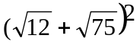 (b) 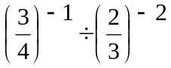
(c) 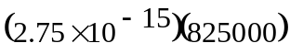 (d) 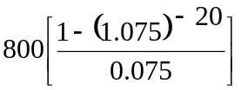
- Solve for x
(a) 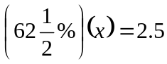 (b) 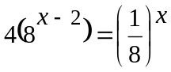
(c) x² – 5x + 6 0 (d) 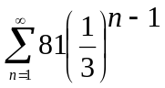
(Show answer on number line)
0
- The perimeter of a rectangle is 32 m. Four times the length is 4 m less than 6 times the width. Find the dimensions of the rectangle. (You must show your equations for full marks.)

- (a) Find the equation of a line that is parallel to 3x- 2y = 5 and passes through (-1,3).
(b) Solve the pair of linear equations, simultaneously.
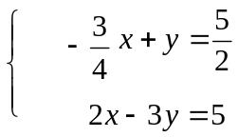
- (a) Sketch the feasible region and determine all the corner points defined by the system.
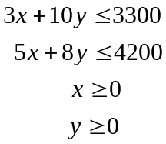
(b) Determine the maximum value for the revenue function f(x,y) = 2x + 4y within the feasible region.
x
y
- a) Sketch a parabola with a vertex at (2,-3) and passing through (4,0) and (0,0).
(b) Find the equation of the parabola in part (a).
Hint: y = a(x – h)² + k
y
x

- Your Grandfather put $75.00 into your education fund starting on the day when you were born, and continuing on that day every month until your 20th birthday. No money was withdrawn from your fund until your 20th birthday. How much would your education fund be worth on your 20th birthday, if money is worth 9% p.a. compounded monthly?

- (a) You purchase a $8000 Canada Savings Bond. It pays 8% p.a. compounded semi-annually. How much is it worth in 12 years?
(b) How long would it take for your money to grow to $15,000.00 in part (a)? (Answer to two decimal places, in years).
- A rectangular garden of area 20 m² is surrounded by a grass border 1.5 m wide. The area of the grass and garden together is 70 m². Use a system of two equations in two variables to find the dimensions of the garden. You must show your work for full marks.
1.5
y
x

- The supply and demand functions for a commodity are given below.
demand: P = 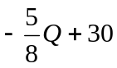
supply: P = 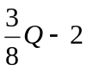
(a) Find the equilibrium point, and graph both functions.
(b) Determine the revenue function. R = P • Q Remember you can only sell what someone will buy.
(c) How much do you need to sell to maximize your revenue?
Hint: Sketch Revenue function
P
R
Q
Q

